Michael S. Zambruski

EDUCATION, TRAINING, and CERTIFICATIONS

M.B.A., Southern Illinois University. Beta Gamma Sigma.
B.S., Georgetown University. Cum Laude.
Project Management Professional (PMP®) certification by the Project Management Institute.
Certified Business Analysis Professional (CBAP®) by the International Institute of Business Analysis.
Advanced Master’s Certificate in Project Management from George Washington University.
Professional Certificate in Business Analysis from George Washington University.
Member of the Project Management Institute and the International Institute of Business Analysis.

TEACHING BACKGROUND

Adjunct Professor for Project Management at University of Connecticut School of Business MSBAPM.
Senior Instructor in strategic planning, project and program management, and business analysis for TwentyEighty Strategy Execution, Inc. and for the Corporate Education Group.
Leadership Coach for MOR Associates, 2014
Adjunct Asst. Professor of International Business and Marketing at Quinnipiac University, 1995-2005.
Lead faculty member for Boston University’s Project Management Evening Certificate Program, 2003.
Instructor for University of Phoenix Online Masters Degree Program, 2001
Adjunct Instructor of International Business and Marketing at Univ. of New Haven Grad School, 1995-99
Teaching over the past 25 years includes the following professional and university courses:
Leading Complex Projects  Leading Project Managers  Introduction to Project Management  Establishing the Project Management Office  Agile Project Management  Business Analysis Fundamentals | Program Management  Program Management for the Federal Government  Risk Management  Steering Strategy to Success  Strategic Alignment of the Project Portfolio

PUBLICATIONS
- Books -

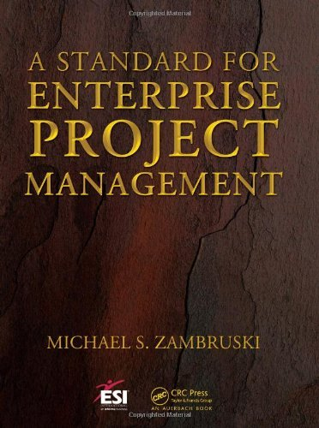 | A Standard for Enterprise Project Management. A complete handbook for project initiation, planning, execution, communication, documentation, closure, and post-implementation evaluation  CRC Press. July 2008. 112 pp.  http://www.amazon.com/Michael-S.-Zambruski/e/B001JRXIU2

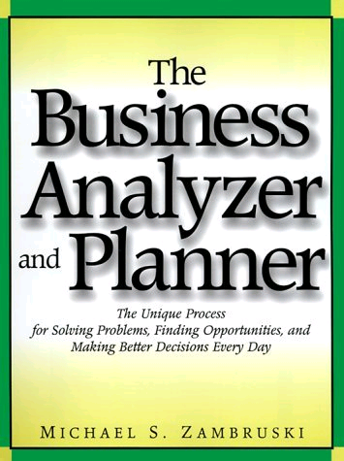 | The Business Analyzer and Planner – The Unique Process for Solving Problems, Finding Opportunities, and Making Better Decisions.  AMACOM Books (American Management Association). 1999. 415 pp.  http://www.amazon.com/Michael-S.-Zambruski/e/B001JRXIU2

- Professional Presentations, Articles, & Research Papers (partial list) -

“The Enterprise Triple Constraint” Integrating strategic planning, business analysis, and program/project management. Published by IIBA in "Best Practices for Better Business AnalysisTM” March 2014, and by ProjectManagement.com (link) October, 2014. Selected for presentation at Project World & Business Analyst World, Toronto and Boston, 2015.

“Understanding and Practicing Project Management as Part of a Business Continuum”, Project Summit & Business Analyst World Conference, Boston. October, 2009.

“Project Management - The Pathway from Ideas to Results, In Any Industry” PMI Southern New England Chapter Annual Conference, Hartford. May, 2008.

“From Chaos to Order” NASA Academy of Sharing Knowledge (ASK). February, 2006.

PROFESSIONAL BACKGROUND

TBA&P, LLC Principal. Business consulting services in strategic planning, business analysis and process (re)design, PMO and Center of Excellence development, project/program/portfolio management, and complex problem solving.

Lucent Technologies Product Director. Worldwide product manager of an entire line of telecom hardware and software products and all associated projects.

SBC Telecommunications Product Director. Responsible for telecommunication services and associated projects budgeted at $90 million.

TRI-S Inc. Vice President. Developed revenue strategy, market segmentation, media campaigns, and the sales force.

Unisys PMO Manager. Built and directed the Project Management Office for the Eastern U.S., with activities ranging up to $50 million in size.

Boeing Program Manager. Program manager for an international IT contract with the U.S. Army.

